**Exercise 1: Implementing the Singleton Pattern**

**Scenario:**

You need to ensure that a logging utility class in your application has only one instance throughout the application lifecycle to ensure consistent logging.

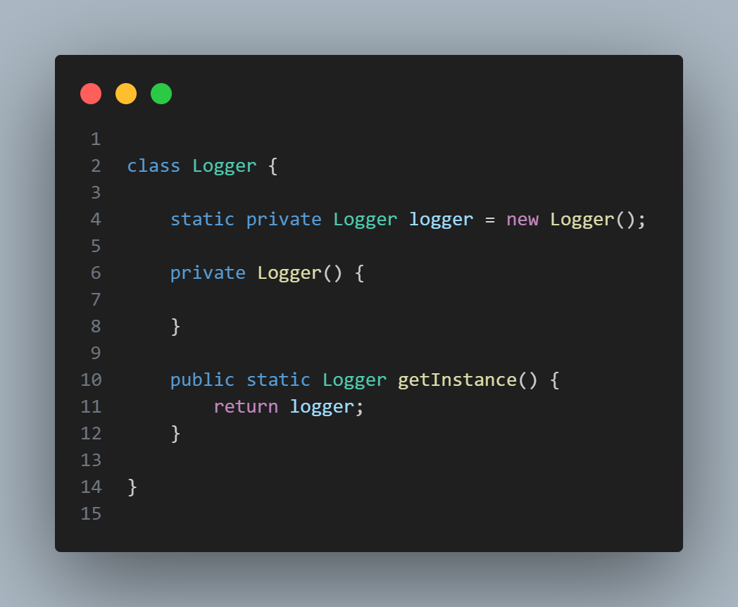

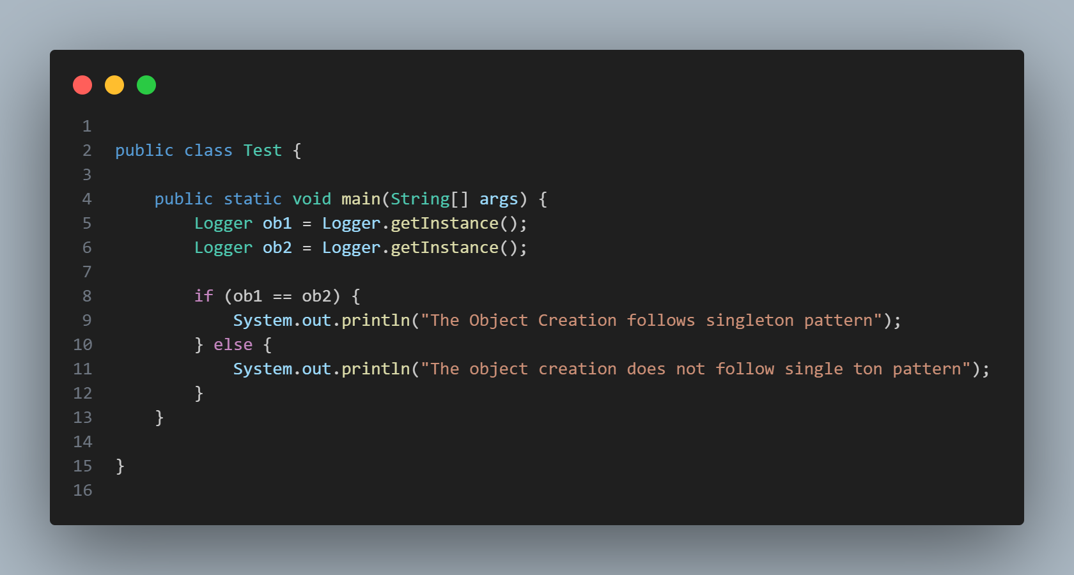

**OUTPUT**

The Object Creation follows singleton pattern